**Individual Project Site Plan**

**Gohouri Ange Junior WDD330**

**Site Purpose**

The goal is to offer fresh and healthy food choices, including organic, made-to-order fruit drinks and fruit bags, catering to both the local community and tourists in coastal areas. The theme should emphasize healthy eating, organic abundance, and convenience.

**Target Audience**

Persona 1: people who eat organic food because they like to eat healthily.

Persona 2: families with children, because parents want to help their children grow up healthy.

**Site Map**

FRESH

ABOUT US

RESOURCE

HOME

**Color Scheme**

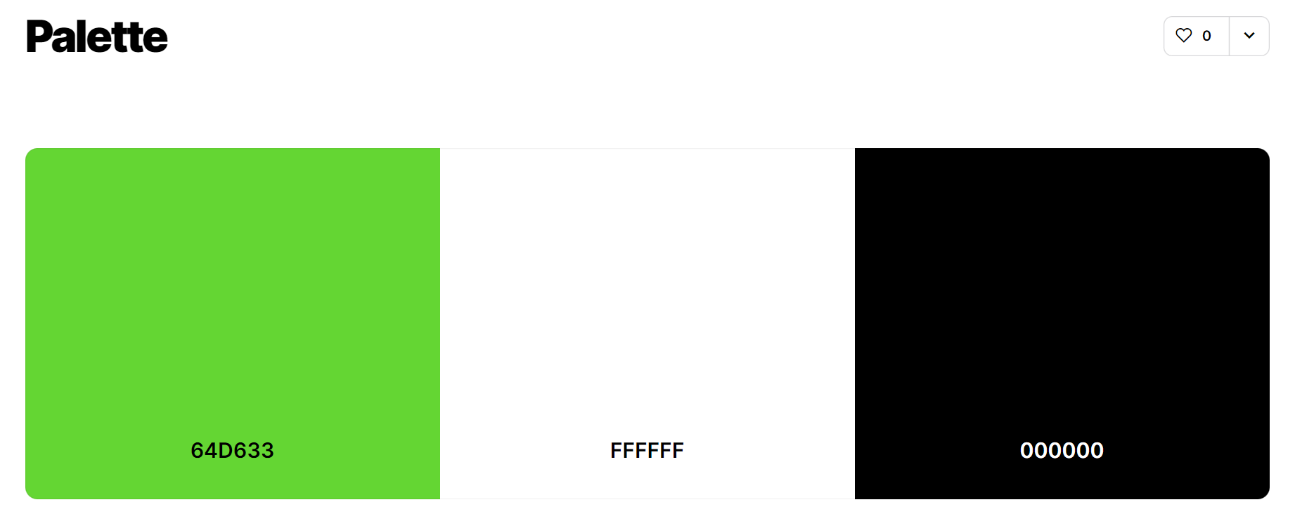

**Typography**

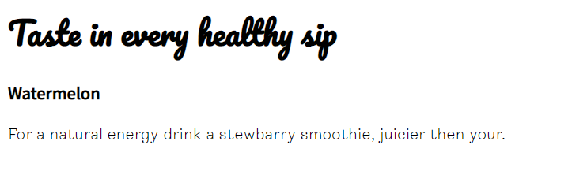

1. Navigation bar, heading, (Noto Sans Kr)
2. Name of products, titles (Pacifico)
3. Paragraph (Solway)

**Wireframe Sketches**

**Large Screen**

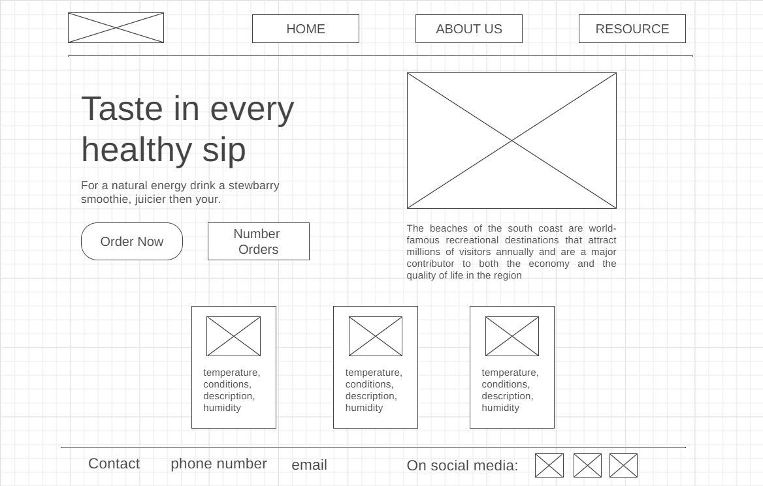

**Medium Screen**

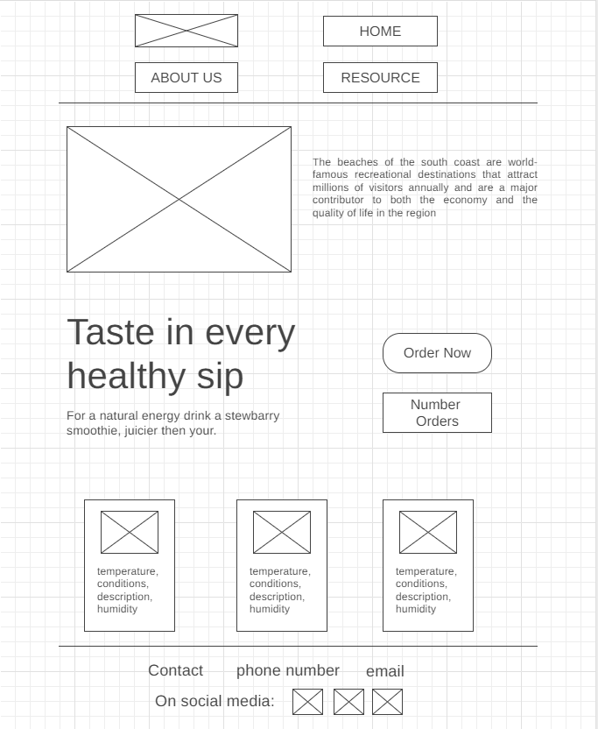

Small Screen

